# 将 Unity 游戏与 Steamworks 集成

## Cloud Saves – 是一种免费存储

官方Steamworks文档

<https://steamworks.github.io/>

桌面的应用内购买解决方案，看起来 Steamworks API 是一个很好的解决方案

<https://blog.theknightsofunity.com/integrating-unity-game-steamworks/>

# 收费Assetstore.unity Steam API - Steamworks Complete

<https://assetstore.unity.com/packages/tools/integration/steam-api-steamworks-complete-246652>

<https://www.youtube.com/watch?v=6ujmZI1qUYI&t=2s>

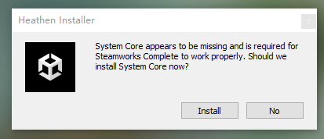

PackageManager's System Core install failed, Error Message: Unable to add package [https://github.com/heathen-engineering/SystemCore.git?path=/com.heathen.systemcore]:

Error when executing git command. error: RPC failed; curl 56 Recv failure: Connection was reset

fatal: expected flush after ref listing

## 导入包SystemCore

<https://github.com/heathen-engineering/SystemCore>

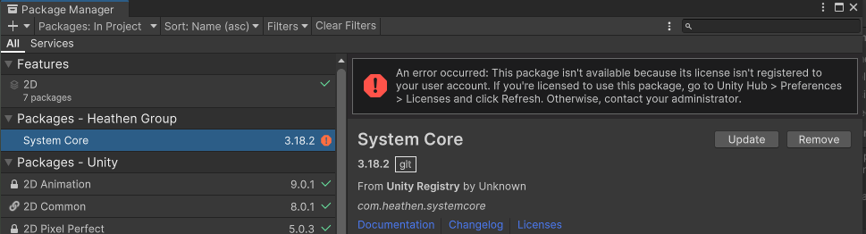

# 比较复杂https://steamworks.github.io/

<https://github.com/rlabrecque/Steamworks.NET>

<https://github.com/rlabrecque/Steamworks.NET-Example>

<https://github.com/rlabrecque/Steamworks.NET-Test>

# 免费Facepunch.Steamworks

<https://github.com/Facepunch/Facepunch.Steamworks>

<https://wiki.facepunch.com/steamworks/>

## MP4 Help

<https://www.youtube.com/watch?v=mr5UpczYQME>

## 登录PC端Steam

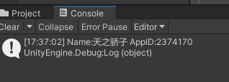

登陆不对应APP ID 的账号，错误提示如下：

|  |
| --- |
| public class SteamAPI_System2023 : MonoBehaviour  {  [Header("应用ID")]  public uint app_id = 2374170;  void Start()  {  try  {  Steamworks.SteamClient.Init(app_id);  ShowYourName();  }  catch(System.Exception e)  {  Debug.LogError(e);  Debug.Log(e.Message);  }  } |

SteamApi_Init returned false. Steam isn't running, couldn't find Steam, AppId is ureleased, Don't own AppId.

# Steamworks Login

## Login

<https://partner.steamgames.com/steamdirect/>

# Unity CloudSaveService

CloudSaveException: Player ID is missing - ensure you are signed in through the Authentication SDK and try again.

Authentication SDK 没有玩家ID

Player id: eDQJddC7lYXVw8Han7mA56335r7f

## 关联Steam Account

IAuthenticationService

Task SignInWithSteamAsync(string sessionTicket, SignInOptions options = null);

Task LinkWithSteamAsync(string sessionTicket, LinkOptions options = null);

# Houdini FxGPT 插件

<https://www.youtube.com/watch?v=mr5UpczYQME>